  


Documentation of Algorithm Analysis and Design

Project for summer ‘19  
“Text Auto-complete”

**Antony Samir.   // 20171702015**

**Caroline Talaat.// 20171701074**

**Lydia George.    // 20171701080**

**Problem Definition:**

Autocomplete is pervasive in modern applications. As the user types, the program predicts the complete query (typically a word or phrase) that the user intends to type. Autocomplete allows the program to predict the value. When a user starts to type in a field, the program should display options to fill in the field, based on earlier typed values.

**Some application on the project:**

1- Search Engines.

2- Text AutoComplete

3- Database Queries.

4- Cell phones use it to speed up text input.

**Input:**

The input file contains the following:

     1. The number of queries N.

     2. N queries, each consists of a query string Q. Each query is in separate line.

The input query contains the following:

     1- String from user.

     2- The choice either using “Edit-Distance” or “Prefix”  algorithms.

**Output:**

The output for file and query search contains the following:

     1. The number of elements  Q after using prefix or edit distance.

     2. The value and the weight for each query output.

**Programming Language and IDE:**

Java, NetBeans.

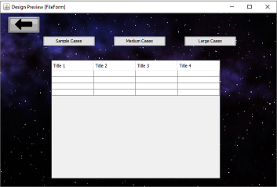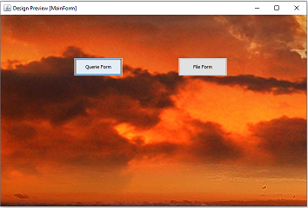**Using a powerful gui to make it easy for user :)**

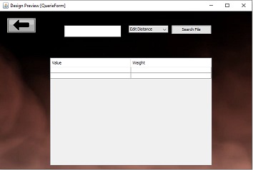

**Running Code:**

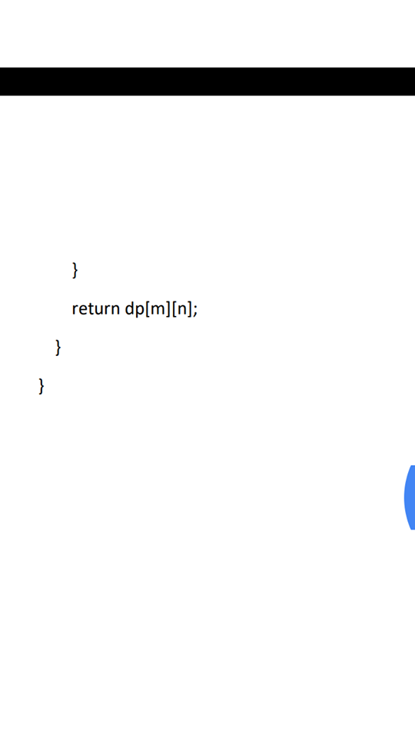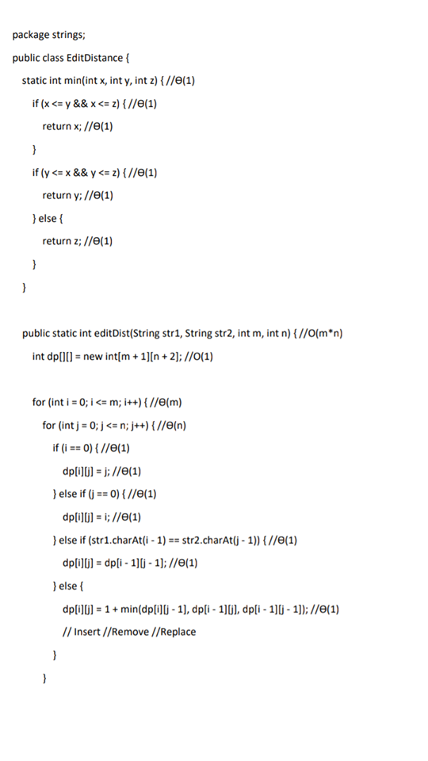Edit Distance Function :-

Prefix Function :-

